**Aim: Develop a menu-driven application that demonstrates the implementation of different Alerts in selenium**

**Code:**

|  |
| --- |
| **package** demo1;  **import** java.time.Duration;  **import** java.util.Scanner;  **import** org.openqa.selenium.By;  **import** org.openqa.selenium.WebDriver;  **import** org.openqa.selenium.chrome.ChromeDriver;  **public** **class** alert {  **public** **static** **void** main(String[] args) **throws** InterruptedException {  // Setup WebDriver  // System.setProperty("webdriver.chrome.driver", "C:/path/to/chromedriver.exe"); // Specify your path here  WebDriver driver = **new** ChromeDriver();  driver.manage().window().maximize();  driver.manage().timeouts().implicitlyWait(Duration.*ofSeconds*(5));  driver.get("https://www.hyrtutorials.com/p/alertsdemo.html");  Scanner scanner = **new** Scanner(System.***in***);  **int** choice;  **do** {  // Display menu  System.***out***.println("Choose an alert type to test:");  System.***out***.println("1. Simple Alert");  System.***out***.println("2. Confirm Alert");  System.***out***.println("3. Prompt Alert");  System.***out***.println("4. Exit");  System.***out***.println("Enter your choice (1-4): ");  choice = scanner.nextInt();  **switch** (choice) {  **case** 1:  // Handle Simple Alert  driver.findElement(By.*id*("alertBox")).click();  org.openqa.selenium.Alert simpleAlert = driver.switchTo().alert();  System.***out***.println("Simple Alert Text: " + simpleAlert.getText());  Thread.*sleep*(3000);  simpleAlert.accept();  **break**;  **case** 2:  // Handle Confirm Alert  driver.findElement(By.*id*("confirmBox")).click();  org.openqa.selenium.Alert confirmAlert = driver.switchTo().alert();  System.***out***.println("Confirm Alert Text: " + confirmAlert.getText());  Thread.*sleep*(6000);  confirmAlert.dismiss(); // You can also use accept() here  System.***out***.println("Output: " + driver.findElement(By.*id*("output")).getText());  **break**;  **case** 3:  // Handle Prompt Alert  driver.findElement(By.*id*("promptBox")).click();  org.openqa.selenium.Alert promptAlert = driver.switchTo().alert();  System.***out***.println("Prompt Alert Text: " + promptAlert.getText());  //Thread.sleep(6000);  promptAlert.sendKeys("Sandeep");  promptAlert.accept();  System.***out***.println("Output: " + driver.findElement(By.*id*("output")).getText());  **break**;  **case** 4:  System.***out***.println("Exiting...");  **break**;  **default**:  System.***out***.println("Invalid choice! Please choose a valid option.");  **break**;  }  } **while** (choice != 4);  // Close the scanner and browser  scanner.close();  driver.quit();  }  } |

Output:

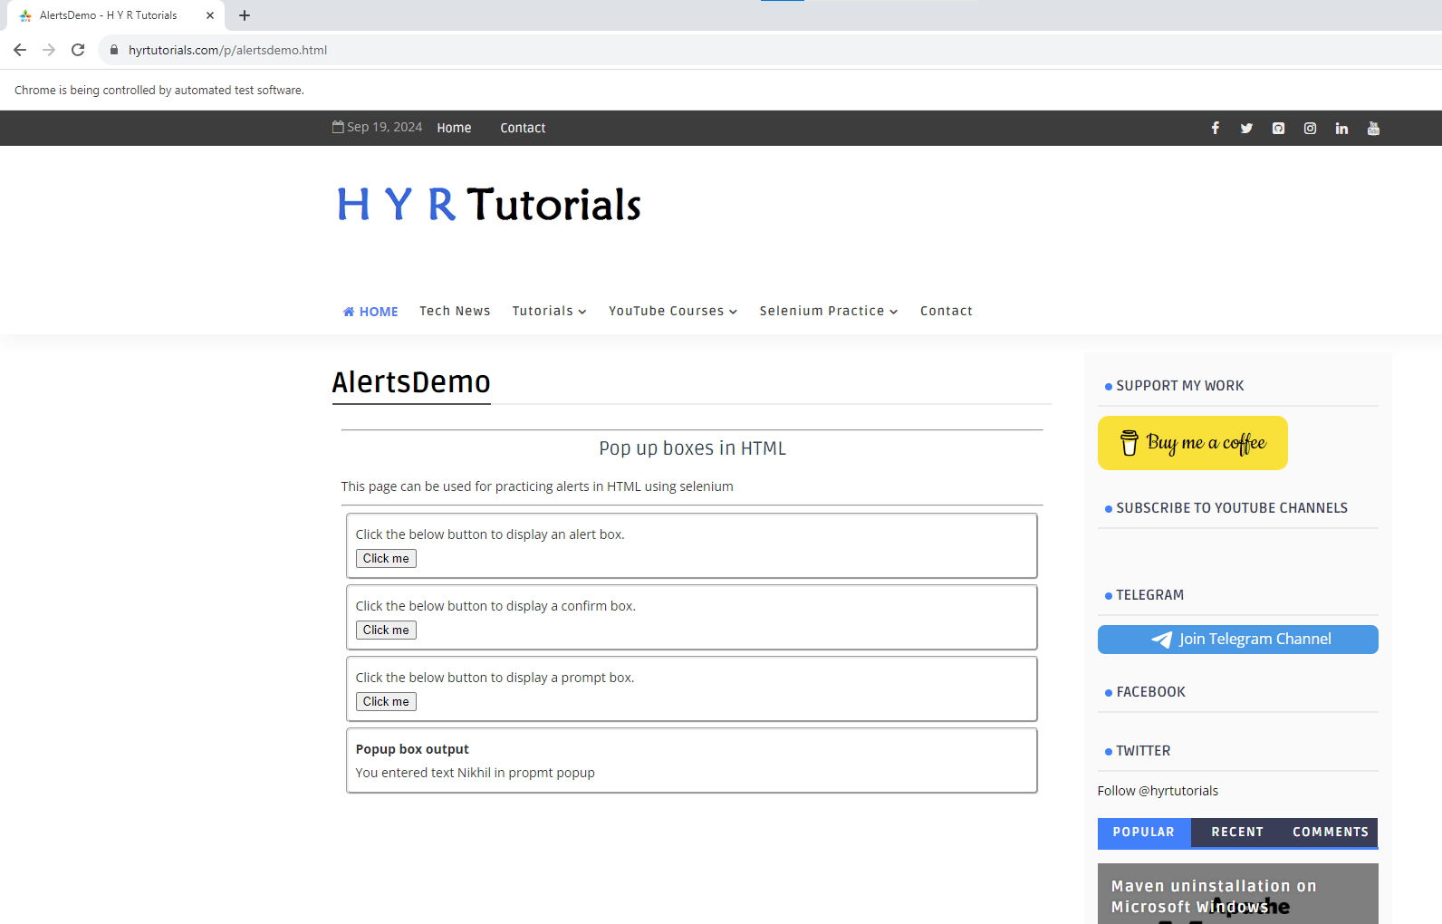

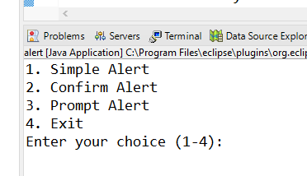

Case 1 : Simple Alert

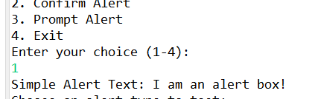

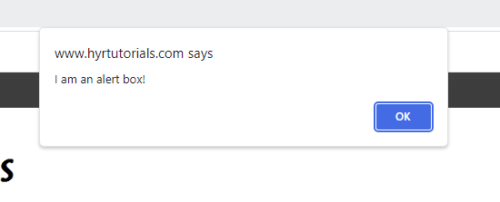

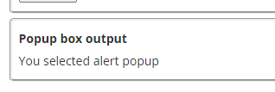

Case 2:

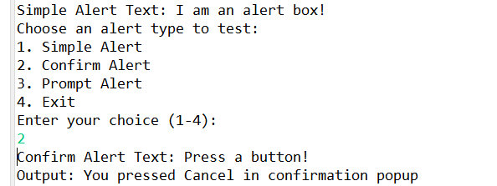

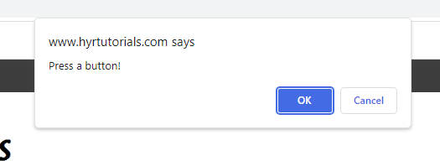

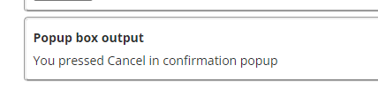

Case 3 :

